  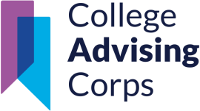

Midtown High School Senior College Prep Packet



Class of 2026

Adam Jolliff and Amel Jackson

College Advisers

Media Center’s College Center

(404) 802 - 3079

**Table of Contents**

Important Senior Contact Information – Pg 2 The College Advisers – Pg 3

Important College Vocabulary- Pg 4-5

Academic Requirements for College- Pg 6-9

Academic Requirements for Technical College/Trade School- Pg 8-9 Which One is for Me?- Pg 9-11

Resources for Building Your College List – Pg 11-12

SAT/ACT – Pg 12-13

What Test Should I Take? - Pg 13-14 Test Prep Resources – Pg 15

Fee Waivers – Pg 15-16

Applying to College – Pg 16-18 Application Deadlines - Pg 16

Free Applications and Fee Waivers- Pg 18 Sending Transcripts – Pg 18

Financial Aid – Pg 19

HOPE/Zell Scholarship – Pg 19 HOPE/Zell Grant – Pg 20

FAFSA - Pg 21-22

Scholarship Information – Pg 23

Twelfth Grade College-Planning To-Do List – Pg 24-27 Military- Pg 28-33

Various Enlistment Routes Steps for Military Enlistment Tattoo Restrictions

ASVAB – Pg 30

Military Recruiter Contact Information – Pg 31 Military Commissioned Officer Route- Pg 32

Workforce – Pg 34

Gap Year/Other Opportunities – Pg 35

|  |  |
| --- | --- |
| Important Senior Contact Information | |
| Graduation Coach | Services Provided   * Checks Student Graduation Progress * Academic Recovery * All Graduation Ceremony Questions |
| Ms. Misty Bryant – [misty.bryant@apsk12.org](mailto:misty.bryant@apsk12.org) |
| College Advisers | Services Provided   * All College Questions * All Career and Military Questions   *\*Extensive List of services below\** |
| Mr. Adam Jolliff - [adam.jolliff@apsk12.org](mailto:adam.jolliff@apsk12.org)  Ms. Amel Jackson - [amel.jackson@apsk12.org](mailto:Jackson-amel.jackson@apsk12.org) |
| Counselors by Last Names | Services Provided   * Letter of Recommendation Requests * Supports Social-Emotional Needs * Supports Academic Needs. * Develops Graduation Plan and Makes Sure Seniors are on Track to Graduate * Facilitates Parent-Teacher Conferences * Dual Enrollment Advisement and Registration * Completes Senior Status Letters * Scheduling |
| Ms. Katrina Rucker (A-E)  [**Katrina.rucker@**apsk12.org](mailto:Katrina.rucker@apsk12.org)  [Book time with Rucker, Katrina: Mrs. Rucker's Senior Advisement Meetings](https://nam11.safelinks.protection.outlook.com/?url=https%3A%2F%2Foutlook.office.com%2Fbookwithme%2Fuser%2Fb9a5528324cb4b5f8251f0f3913fd79b%40apsk12.org%2Fmeetingtype%2F8P4Qim-7wkmlnMjAQesY2A2%3Fanonymous%26ep%3Dmcard&data=05%7C02%7CMidtownCounselor%40atlanta.k12.ga.us%7C90454ef78163412af74b08ddd69c16f8%7C0d95ef40a0dd431890985e10f876f635%7C0%7C0%7C638902688101358306%7CUnknown%7CTWFpbGZsb3d8eyJFbXB0eU1hcGkiOnRydWUsIlYiOiIwLjAuMDAwMCIsIlAiOiJXaW4zMiIsIkFOIjoiTWFpbCIsIldUIjoyfQ%3D%3D%7C0%7C%7C%7C&sdata=HsMnusS6S0af5E2ccYOUpKtqnPNuZK9%2FWEUJAw%2FLUpU%3D&reserved=0)  Ms. Christina Brantley (F-K)  [**Christina.Brantley@**apsk12.org](mailto:Christina.Brantley@apsk12.org)  [Book time with Brantley, Christina: Senior Advisement Meeting with Ms. Brantley | Class of 2026](https://nam11.safelinks.protection.outlook.com/?url=https%3A%2F%2Foutlook.office.com%2Fbookwithme%2Fuser%2F54682b406e4646d689b6c76bafa63856%40apsk12.org%2Fmeetingtype%2FLaf4WlpMzkCN3O9BxFTfMw2%3Fanonymous%26ismsaljsauthenabled%26ep%3Dmcard&data=05%7C02%7CMidtownCounselor%40atlanta.k12.ga.us%7C90454ef78163412af74b08ddd69c16f8%7C0d95ef40a0dd431890985e10f876f635%7C0%7C0%7C638902688101371594%7CUnknown%7CTWFpbGZsb3d8eyJFbXB0eU1hcGkiOnRydWUsIlYiOiIwLjAuMDAwMCIsIlAiOiJXaW4zMiIsIkFOIjoiTWFpbCIsIldUIjoyfQ%3D%3D%7C0%7C%7C%7C&sdata=Yqpt8RMTXv1vrXAti3zX7SfLBUBYKRWFDgcDpbyl53M%3D&reserved=0)  Mr. Amari BenLevi (L-R)  [Amari.Benlevi@apsk12.org](mailto:Amari.Benlevi@apsk12.org)  [Book time with Benlevi, Amari: BenLevi's L-R Senior Conference Sign-Up 2025-2026](https://nam11.safelinks.protection.outlook.com/?url=https%3A%2F%2Foutlook.office.com%2Fbookwithme%2Fuser%2F9208a0fe1d204c2490efb06b5c031717%40apsk12.org%2Fmeetingtype%2F-viQkPs8D06PPyBGM1VJEA2%3Fanonymous%26ismsaljsauthenabled%26ep%3Dmcard&data=05%7C02%7CMidtownCounselor%40atlanta.k12.ga.us%7C90454ef78163412af74b08ddd69c16f8%7C0d95ef40a0dd431890985e10f876f635%7C0%7C0%7C638902688101384558%7CUnknown%7CTWFpbGZsb3d8eyJFbXB0eU1hcGkiOnRydWUsIlYiOiIwLjAuMDAwMCIsIlAiOiJXaW4zMiIsIkFOIjoiTWFpbCIsIldUIjoyfQ%3D%3D%7C0%7C%7C%7C&sdata=60l8WG%2BNeSvfodh8JDhh022akztRRn%2BF%2BbUeFGLVkJY%3D&reserved=0)  Dr. Chelsea Falcone (S-Z)  [**Chelsea.falcone@**apsk12.org](mailto:Chelsea.falcone@apsk12.org)  [https://www.signupgenius.com/go/805094BAFA72DAAFB6-50488412-drfalcones#/](https://nam11.safelinks.protection.outlook.com/?url=https%3A%2F%2Fwww.signupgenius.com%2Fgo%2F805094BAFA72DAAFB6-50488412-drfalcones%23%2F&data=05%7C02%7CMidtownCounselor%40atlanta.k12.ga.us%7C90454ef78163412af74b08ddd69c16f8%7C0d95ef40a0dd431890985e10f876f635%7C0%7C0%7C638902688101401763%7CUnknown%7CTWFpbGZsb3d8eyJFbXB0eU1hcGkiOnRydWUsIlYiOiIwLjAuMDAwMCIsIlAiOiJXaW4zMiIsIkFOIjoiTWFpbCIsIldUIjoyfQ%3D%3D%7C0%7C%7C%7C&sdata=hDdkkZxbHgGPUv%2FGg0vMYpVN6J4mbTA3oUX6GiZLeQA%3D&reserved=0) |
| Administrators  Dr. Betsy Bockman- ***Principal*** (10-12th F-G) [bbockman@atlanta.k12.ga.us](mailto:bbockman@atlanta.k12.ga.us) | Services Provided   * Letter of Recommendation Requests * All Discipline and Parent Concerns |
| Ms. Melissa Davis- ***AP*** (10-12th A-E) [mldavis@atlanta.k12.ga.us](mailto:mldavis@atlanta.k12.ga.us)  Ms. Carrie MacBrien-***AP*** (10-12th H-K) [cmacbrien@atlanta.k12.ga.us](mailto:cmacbrien@atlanta.k12.ga.us)  Ms. Jennifer Cappelli -***AP*** (10-12th L-R) [jcappelli@atlanta.k12.ga.us](mailto:jcappelli@atlanta.k12.ga.us)  Mr. Rodney Howard- ***AP*** (10-12th S-Z) [rdhoward@atlanta.k12.ga.us](mailto:rdhoward@atlanta.k12.ga.us)  Mr. Willie Vincent – ***AP*** (all 9th grade) [wmvincent@atlanta.k12.ga.us](mailto:wmvincent@atlanta.k12.ga.us) |

## Meet the College Advisers

|  |  |
| --- | --- |
| Amel Jackson (Lau-Z) [amel.jackson@apsk12.org](mailto:amel.jackson@apsk12.org) | Adam Jolliff (A-Lan) [adam.jolliff@apsk12.org](mailto:adam.jolliff@apsk12.org) |

We are the College Advisers for all students at Midtown High School. We help students with:

|  |  |
| --- | --- |
| * Major/Career Exploration | * College Applications |
| * College Match/Fit | * FAFSA Completion |
| * SAT/ACT Test Registration | * Housing/Meal Plans |
| * Resume Building | * Anything Else Related to Post- Secondary Plans |

***All senior students are required to meet with an adviser at least once a semester***, but they are strongly encouraged to meet with us as many times as they need to. Many students in the Class of 2025 met with college advisers over 20 times a semester! Students and parents can schedule a meeting with us using the link below or by scanning our QR code.

Our QR code can be found on the counseling office door, email signature, and flyers. The College & Career Center website will also be linked below. Both will be updated with important senior links throughout the year.

Website: <https://www.midtownhighccc.com/> Linktree: <https://linktr.ee/midtownccc>

Important College Vocabulary

###### Financial Aid

* **HOPE/Zell Miller Scholarship**: A Georgia scholarship program that pays for a percentage of a student’s tuition at a public college in Georgia based on high school grades for an associate or bachelor’s degree. More information will be provided below.
* **HOPE/Zell Miller Grant:** A Georgia scholarship program that pays for a percentage of a student’s tuition at a public trade school in Georgia based on high school grades for a diploma or certificate program. More information will be provided below.
* **HOPE Career Grant:** Extra funding for students who receive the HOPE & Zell Grants. Given for specific programs that are in high demand in Georgia. More information will be provided below.
* **Free Application for Federal Student Aid (FAFSA):** This application is required to receive funding from the federal government. Money is given on a first-come, first served basis, and there is a limited amount. Fill it out as soon as possible! Students will automatically be applied to the HOPE/Zell Scholarships and Grants when they complete FAFSA. More information will be provided below.
* **Pell Grant**: Special funding the government provides for low-income students to pay for college. Unlike a loan, the Pell Grant does not have to be repaid. For the 2025-26 school year, students were eligible to receive up to $7,395 for their first year of college.
* **CSS Profile:** A financial aid application similar to FAFSA that many private colleges use to determine a student’s need for aid aside from the FAFSA. The FAFSA is still required!

###### College Admission Tests

* **Test Optional:** Some colleges don’t require admission tests to apply. This may depend on the student’s GPA. Tests may still be required for scholarships or other programs
* **SAT:** One of two college admissions tests for students interested in a four-year college. The SAT is administered by College Board and is scored out of 1600 points. Scores are based on the Evidence-Based Reading and Writing (800 pts) and Math (800 pts) sections. More information will be provided below.
* **ACT:** One of two college admissions tests for students interested in a four-year degree. The ACT administers the ACT and is scored out of 36 points. Scores are based on the

average of the English (36 pts), Math (36 pts), Reading (36 pts), and Science (36 pts) sections. More information will be provided below.

* **ACCUPLACER**: This is a placement test used for two-year and technical colleges. It can be used instead of the SAT or ACT and helps determine what classes a student will start with upon entering into a certificate, diploma, or associate’s program.

###### Degree Types

* **Certificate:** Students can specialize in a field without investing the time needed to earn a four-year degree. Certificates are typically 5 or 6 courses taken over a period of time. The price and length of a certificate depends on the program. Typically, less than one year.
* **Associate’s degree**: These programs usually provide a more thorough, in-depth examination of a particular field, like healthcare or technology. Typically, two years.
* **Bachelor’s degree:** Provided at traditional colleges and universities. It involves around three semesters of general education courses (in the same core subjects) and around nine semesters of in-depth study into a particular subject area. Also called a four year degree.

###### Application Types

* **Early Action:** This is an application deadline to determine an early pool of applicants. This application is nonbinding, meaning students don’t have to commit to the college if they’re accepted. Sometimes, colleges and universities offer early action applicants extra scholarship opportunities, honors college opportunities, or other special programs.
* **Early Decision:** This is an application deadline to determine an early pool of applicants. However, this application is **binding**, and **requires that a student attends the university**. Sometimes, colleges and universities offer early decision applicants extra scholarship opportunities, honors college opportunities, or other special programs.
* **Regular Decision:** This application type ensures that applicants have submitted their materials by a specific deadline. This is the last deadline to apply to a school for the upcoming school year. The decisions go out on a set date, later in the year than early action or early decision, which does not change based upon the date the application was submitted.
* **Rolling Admissions:** This application type allows for decisions to be shared as soon as the admissions officer has received all the applicant’s required materials.

###### Application Decision Types

* **Accepted:** The student was accepted with no conditions.
* **Provisional/Conditional Acceptance:** The student was accepted but must maintain the requirements listed by the college. Ex: accepted, but needs to keep their GPA above a 2.5
* **Waitlisted:** There were limited spots available for freshman students. The student must accept their spot on the waitlist. When an accepted student denies their acceptance, the next student on the waitlist will be offered the acceptance.
* **First-Year Transfer:** Some colleges offer transfer programs for students who applied. Students would have to take their first year of classes at another college and would be able to transfer to the desired college if they maintain the academic requirements for the transfer program. Ex: Georgia Tech.
* **Deferred:** Typically given to earlier applications. The college hasn’t finished reviewing your application and would like to review it with applicants from a later admission deadline.
* **Denied:** The student was not accepted into the college This can be due to academics, extracurricular activities, and other reasons.

*A comprehensive list of College Definitions can be found on the CCC website* [*MHS College Access*](https://docs.google.com/document/d/1O0rE93TP8PwvwA8jn0Xp2Rk7CGE7yspmwuJ8mtqLSDk/edit?usp=sharing)[*Vocabulary*](https://docs.google.com/document/d/1O0rE93TP8PwvwA8jn0Xp2Rk7CGE7yspmwuJ8mtqLSDk/edit?usp=sharing)

### Academic Requirements for College

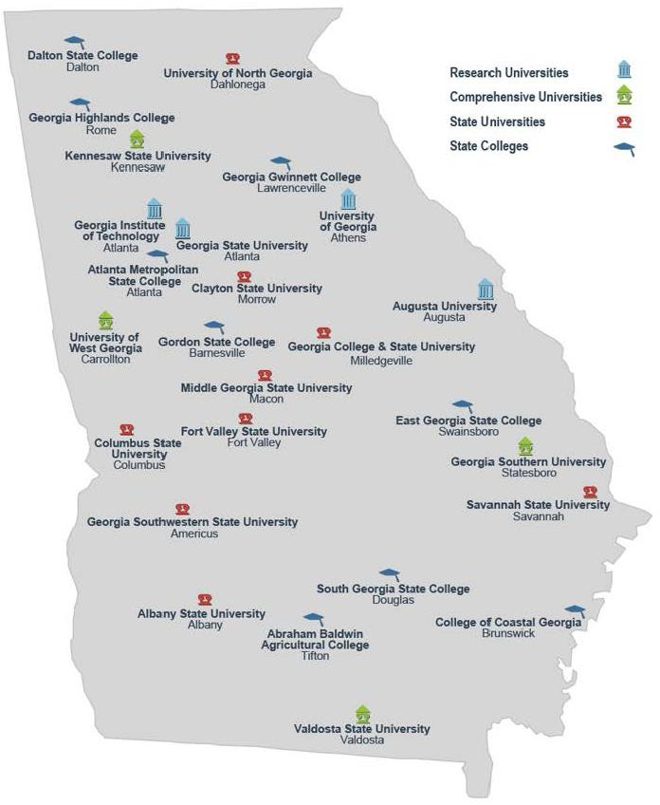The University System of Georgia (USG) is the government agency that runs all 26 public colleges and universities in Georgia. These institutions are broken into four types:

* + Research University
  + Comprehensive University
  + State University
  + State College

Institutions are categorized based on the type of degrees they offer to students.

In order to apply to a USG institute, students must meet the academic requirements listed below. USG requires students to complete the following 17

Required High School Curriculum (RHSC) to apply to their colleges. Many of these credits overlap with class required to graduate, but not all:

* 4 units of English
* 4 units of mathematics
* 4 units of science
* 3 units of social science
* 2 units of the same foreign language, American Sign Language, or computer science

For the Fall 2026 semester, most USG schools will be ending their test optional policies and requiring applicants to submit SAT or ACT scores. Of the four types of intuitions listed above, only state colleges will remain test optional. A list of these schools can be found below. Students who planned to apply without test scores should make plans to take the SAT or ACT as soon as possible to give time for multiple attempts.

State Colleges (Test optional): Abraham Baldwin Agricultural College, Atlanta Metropolitan State College, College of Coastal Georgia, Dalton State College, East Georgia State College, Georgia Gwinnett College, Georgia Highlands College, Gordon State College and South Georgia State College.

##### Freshman Index

In addition to meeting the Required High School Curriculum (RHSC), high school GPA, and SAT/ACT score requirements, students must meet the minimum Freshman Index (FI) for the college. The FI is calculated using the student’s GPA and SAT/ACT scores. The formulas for Freshman Index are below:

|  |  |
| --- | --- |
| ACT  FI = 500 x (GPA) + (ACT Score x 42) + 88 | SAT  FI = 500 x (GPA) + 1.06 x (SAT score) - 74 |

*The Freshman Index formula may be different at non-USG institutions. *

##### Additional Requirements

As mentioned above some colleges may have additional requirements to apply depending on the major. For example, KSU requires higher SAT/ACT scores for students applying to the architecture program. Nearly all nursing programs require higher SAT/ACT scores than what was required for the college, so it’s important for students to see if there are additional requirements for what they want to do.

##### Common Additional Requirements

* Additional application for the program/major once admitted
* Higher SAT/ACT scores based on the program/major
* Additional foreign language requirements for the college/program/major
* Additional fine arts requirements for the college/program/major

Students can check the specific requirements of a college on their admissions website and requirements for the major:

* For Colleges
* Google > “College Name” Admission Requirements > Freshman/First Time College Students > View Requirements
* For Majors
* Google > “College Name” “Major” Requirements > Required Curriculum > View Requirements

### Academic Requirements for Technical College/Trade School

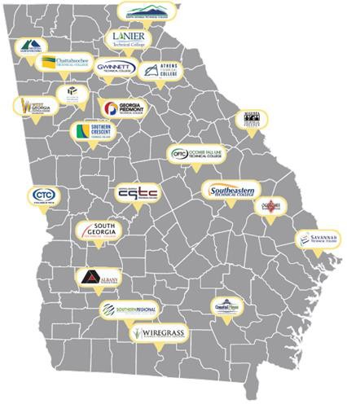The Technical College System of Georgia is the government agency that runs all 22 public technical colleges/trade schools in Georgia. These technical colleges offer:

* + 88 Locations
  + Trade School Programs
  + Tuition Free Programs
  + Transfer Pathways to USG Schools

These institutions may be called “junior colleges” or “community colleges”.

There are fewer academic requirements for technical colleges. Students need a high school diploma or its equivalent and qualifying

placement tests. The following metrics may be used for placement at a technical college:

* SAT/PSAT
* ACT/Pre-ACT
* TABE 9-10
* TABE 11/12
* Georgia Milestones
* HOPE GPA
* High school GPA
* GED® Scores
* HiSET® Scores
* TCSG Approval Form
* Accuplacer/Companion
* Compass/Asset

Each technical college uses different metrics, so check with the schools before applying.

### Which One is for Me?

##### Technical College vs. Traditional College

* + Technical Colleges are often cheaper than traditional colleges, but they offer fewer scholarships for students
  + Traditional colleges have more clubs, sports, and activities for students
  + Only two technical colleges (North Georgia and South Georgia) have on-campus housing, but most USG colleges have on-campus housing
  + Traditional Colleges may require you to live on-campus for a certain amount of time, while you can live wherever you want at a technical college
  + Technical Colleges require a high school diploma and a variety of tests for acceptance, but traditional USG colleges have a GPA and SAT/ACT requirement
  + Technical Colleges only offer certificates, diplomas, and two-year degrees
  + More information on technical careers, training, and professions can be found [here.](https://www.beprobeproudga.org/about-bpbp)

##### In-State vs. Out-of-State

* + Students applying to any college in Georgia will be applying for in-state tuition
  + Out-of-State colleges charge out-of-state tuition, which is typically 300% higher than In- State tuition
  + The HOPE/Zell Scholarship/Grant only applies to in-state colleges
  + Most college classes at public universities in Georgia will be accepted at other public universities in Georgia, but it’s not likely that out of state college classes will transfer

##### Public School vs. Private Schools

* + Private colleges cost more than public schools, but tend to offer more scholarships and financial aid
  + Private colleges offer more specialized majors compared to public colleges

##### How does GPA affect college options?

Many colleges will list a minimum GPA required to apply. This is typically a 2.0 or 2.5 GPA. Some colleges won’t even list a minimum GPA. However, this ***does not mean*** that GPA doesn’t matter. Admissions Officers consider the academic standards set by students at their college. For example, Georgia Tech has no minimum GPA listed on their website, admissions criteria, or Freshman Profile; however, around 85% of Tech's students have a 4.0 unweighted GPA.

Because ***so many*** students apply to Tech and ***so many*** students who have competitive (above a 3.5) GPAs, Georgia Tech gets to be picky and choose students with more extracurriculars.

##### Building a Balanced College List

Students are encouraged to apply to at least one school in each ***academic match*** category:

|  |  |  |
| --- | --- | --- |
| **Likely** | **Match** | **Reach** |
| Student has GPA, Test Scores, and Course Rigor ***above*** college averages  Allows students to have as many options for college as possible | Student has GPA, Test Scores, and Course Rigor ***meet*** college averages  Allows students to have their passions and academics matched by their peers | Student has GPA, Test Scores, and Course Rigor ***below*** college averages  Allows students to compete for acceptance at a school they want to go to |

###### *Not all colleges will offer your major. Check before applying! *

In addition to academics, students should look at their ***personal fit*** at the colleges. Things to consider include:

* + Cost of Attendance
  + School Demographics
  + Extracurricular Activities Available
  + On-Campus Housing style
  + Weather/Location

**Resources for Building Your College List**

###### Books:

Steven Antonoff, *College Match: A Blueprint for Choosing the Best School for You* (much of this information can also be found on the Schoolbuff.com website)

Frank Bruni, *Where You Go Is Not Who You’ll Be*

*Fiske Guide to Colleges* (This old-style reference book is available in the CCC). There is an online, interactive version of the Fiske Guide available for $19.99 for a 12-month subscription on (collegecountdown.com).

###### Websites:

[College Essay Guy](https://www.collegeessayguy.com/) (<https://www.collegeessayguy.com/>)

* + This website includes many great college resources, including his guide to finding a college (<https://www.collegeessayguy.com/blog/how-to-choose-a-college>).

[Schoolbuff](https://schoolbuff.com/resources-and-books/worksheets/) (<https://schoolbuff.com/resources-and-books/worksheets/>)

* + Find questionnaires that will help you know yourself” Self-survey for the College Bound; College Planning Values Assessment: Self-knowledge Questionnaire; Qualities that Will Make a College Right for You, etc.)

[Collegexpress.com](https://www.collegexpress.com/) (<https://www.collegexpress.com/>)

* + Search a variety of lists for schools outside of the usual rankings (schools for the free spirit, for example), search for scholarships and summer programs, and compare schools. Has many lists from Antonoff’s book, *College Finder.*

[GAfutures](https://www.gafutures.org/) (<https://www.gafutures.org/>)

* + A great guide to in-state colleges. You can also apply for or find more information about financial aid here.

[College Scorecard](https://collegescorecard.ed.gov/) (<https://collegescorecard.ed.gov/>)

* + This site from the US Department of Education offers lots of reliable data and statistics to help you compare schools (four-year and two-year).

[Cappex](https://www.cappex.com/) (<https://www.cappex.com/>)

* + Create a profile that goes well beyond test scores and grade-point averages to help you discover interesting schools that you might not have heard of. Scholarship information is also available.

[College Board](https://www.collegeboard.org/) (https://[www.collegeboard.org/)](http://www.collegeboard.org/))

* + Search for schools, view statistics on the academic profile of a college’s freshman class, financial aid and merit aid stats, available majors, and much more. Also, this is where to register for the SAT.
  + [Big Futures](https://bigfuture.collegeboard.org/college-search) is a great tool to build you college list

[College Navigator](https://nces.ed.gov/collegenavigator/) (https://nces.ed.gov/collegenavigator/)

* + This federal website contains tons of data on the nation’s colleges and universities.

[College Confidential](https://www.collegeconfidential.com/) (https://[www.collegeconfidential.com/)](http://www.collegeconfidential.com/))

* + Search for schools and find lots of great articles and forums on all aspects of the college process.

[Unigo](https://www.unigo.com/) (https://[www.unigo.com/)](http://www.unigo.com/))

Search for schools, and also read thousands of reviews from the students themselves.

**SAT/ACT -** What Test Should I Take?

The SAT and ACT are both college admissions tests for colleges. Colleges will accept either test as long as students have the required scores. Think of it as the fruit requirement for lunch: students can take an apple, an orange, or both, but they’re required to take at least one fruit. The tests are slightly different.

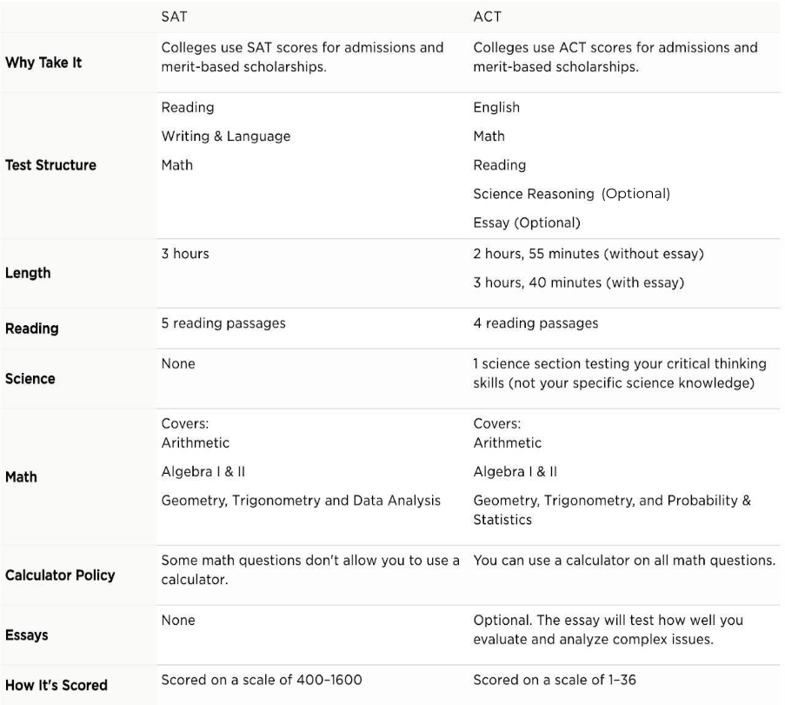

Important Differences

* + Science
* The ACT’s science section is now optional. This section tests science reasoning, meaning the questions will be about comprehending scientific concepts from passages and figures in the test, not memorization of scientific concepts. Students applying to a STEM based major should take this section if they chose ACT.
* The SAT has no science option.
  + Math
    - ACT lets you have a calculator the whole section, SAT does not
    - SAT has write in questions ([example](https://satsuite.collegeboard.org/media/pdf/official-sat-study-guide-sample-math-questions-student-produced-response.pdf))
  + Reading
    - ACT focuses on reading comprehension so skimming is encouraged
    - SAT has two-part evidence-supported questions that the ACT doesn't have. These are two questions that are related to each other. The answer to one question is linked to the answer to the one before it. If students answer incorrectly on question one, they are likely to answer incorrectly on question two.

# 2025-2026 SAT/ACT National Test Dates

2025-2026 ACT Test Dates and Registrations

2025-2026 SAT Test Dates and Registrations

| SAT Test Date | Registration Deadline | Scores Release Date | Suggested Prep Dates |
| --- | --- | --- | --- |

|  |  |  |  |
| --- | --- | --- | --- |
| August 23, 2025 | August 8, 2025 | September 5, 2025 | [Start June 2025](https://www.princetonreview.com/college/sat-honors-course?ceid=test-dates) |

|  |  |  |  |
| --- | --- | --- | --- |
| September 13, 2025 | August 29, 2025 | September 26, 2025 | [Start June 2025](https://www.princetonreview.com/college/sat-honors-course?ceid=test-dates) |

|  |  |  |  |
| --- | --- | --- | --- |
| October 4, 2025 | September 19, 2025 | October 17, 2025 | [Start July 2025](https://www.princetonreview.com/college/sat-honors-course?ceid=test-dates) |

|  |  |  |  |
| --- | --- | --- | --- |
| November 8, 2025 | October 24, 2025 | November 21, 2025 | [Start September 2025](https://www.princetonreview.com/college/sat-honors-course?ceid=test-dates) |

|  |  |  |  |
| --- | --- | --- | --- |
| December 6, 2025 | November 21, 2025 | December 19, 2025 | [Start October 2025](https://www.princetonreview.com/college/sat-honors-course?ceid=test-dates) |

|  |  |
| --- | --- |
| Test Prep Resources | |
| SAT   * [Khan Academy](https://www.khanacademy.org/test-prep/sat) * [Full-Length Practice Tests](https://satsuite.collegeboard.org/sat/practice-preparation/practice-tests) * [Paid Classes](https://www.varsitytutors.com/courses/sat-prep-hs-free/dp/d8d567cb-aed5-4cd5-a241-244fcd67ce3b) * [Union SAT Test Prep](https://uniontestprep.com/sat-exam) * [Magoosh SAT Test Prep](https://magoosh.com/hs/sat/sat-practice-test/) * Math Brain Booster Phone App | ACT   * [Kaplan Test Prep](https://kaplan.com/all-prep)   + Free with ACT Waiver * [Official ACT Test Prep](https://www.act.org/content/act/en/products-and-services/the-act/test-preparation/free-act-test-prep.html) * [Mometric ACT Test Prep](https://www.testprepreview.com/act_practice.htm) * [Union ACT Test Prep](https://uniontestprep.com/act) * [Magoosh ACT Test Prep](https://magoosh.com/hs/act/act-practice-test/) * Math Brain Booster Phone App |

##### Fee Waivers

11th & 12th grader students are eligible to take the SAT/ACT and send their scores for FREE if they meet at least one of the requirements below:

* + Family’s annual family income falls within the Income Eligibility Guidelines set by the USDA Food and Nutrition Service.
  + Student or a member of their immediate family is enrolled in a federal, state, or local program that aids students from low-income families (e.g. Federal TRIO programs such as Upward Bound).
  + Family receives public assistance.
  + Student lives in federally subsidized public housing, a foster home or is homeless.
  + Student is a ward of the state or an orphan.
  + Student or another child in their household receives free or reduced meals

Additional information about eligibility requirements for fee waivers can be found [here](https://satsuite.collegeboard.org/sat/registration/fee-waivers/fee-waiver-eligibility) for the SAT and [here](https://www.act.org/content/dam/act/unsecured/documents/FeeWaiver.pdf) for the ACT.

##### To Receive a Fee Waiver:

Students must have completed the [free/reduced lunch application](https://www.myschoolapps.com/Home/PickDistrict) and qualified for free/reduced lunch. After completion, students should email their counselor requesting a fee waiver code. If approved for a fee waiver, the counselor will send the code via email. The same fee waiver form is used for application fee waivers. The [ACT fee waiver benefits](https://www.act.org/content/act/en/products-and-services/the-act/registration/fees/fee-waivers.html) allow students

to receive four waivers and free access to [The Official ACT Self-Paced Course, powered by](https://www.act.org/content/act/en/products-and-services/the-act/test-preparation/act-kaplan.html) [Kaplan.](https://www.act.org/content/act/en/products-and-services/the-act/test-preparation/act-kaplan.html) The [SAT fee waiver benefits](https://satsuite.collegeboard.org/sat/registration/fee-waivers/fee-waiver-benefits) include students can receive one waiver valid for two tests.

### Applying to College

##### Application Deadlines

Before you start your college application, there are a few things you need to know. The most important thing to know is when deadlines are. ***Unlike in high school, college deadlines are strict***. If you miss the application deadline or document submission deadline, your application will not be accepted. Different types of applications have different deadlines:

* + **Early Action:** Typically, in October or November. Colleges will usually offer extra scholarship opportunities, honors college, or other special programs.
  + **Early Decision:** Typically, in October or November. Colleges will usually offer extra scholarship opportunities, honors college, or other special programs. However, this application is ***binding***, and ***requires that a student attends the university***. If accepted, students ***have to attend*.**
  + **Regular Decision:** Ranges from January all the way to June. This is a regular deadline students have to submit documents.

##### How to Apply - platform?

There are four main locations students would apply to college:

* + [**GAFutures**](https://www.gafutures.org/)**:** Hosts the location of nearly all applications for colleges in Georgia. Many colleges have their application through GAFutures like Kennesaw and Clayton.
  + [**Common App**](https://www.commonapp.org/)**:** One application used by 950+ colleges internationally. Multiple colleges in Georgia use it including UGA, Georgia State, Georgia Tech, and Spelman.
  + [**Common Black College App**](https://commonblackcollegeapp.com/)**:** One application used by 66 HBCUs including Alabama State University, Tuskegee, and Bethune-Cookman.
  + **Institution Website**: An application hosted on the college’s website. Some colleges may have their own application in addition to one on any of the other locations.

Students will have to make their own accounts to apply on any given platform. Make sure to ***use your personal email address*** on all applications. Your Atlanta Public School email address will not be available to your post-graduation, so in order to keep access to all of your accounts and applications, you ***must use your personal email address.***

***Colleges see what your personal email address is! Embarrassed? Make an email specifically for college. A basic one could be [First.Last.classof2025@gmail.com](mailto:First.Last.classof2025@gmail.com). That would be [Wendy.Warhawk.classof2025@gmail.com](mailto:Wendy.Warhawk.classof2025@gmail.com) when filled out. All college emails can go here!***

##### What’s Needed to Apply

Colleges may require different items depending on academic rigor, competitiveness, and school type. Here’s a list of what colleges will require the most to least:

* + All colleges require: Completed Application, Transcripts, Application Fee (if applicable)
  + Many colleges require: SAT/ACT scores, Letters of Recommendation, Essay(s)
  + Some colleges require: Additional portfolio (typically for fine arts degrees), alumni interview (typically for prestigious universities)

Students can learn how to submit the following documents below:

* + **Completed Application:** Through the application portal.
  + **Transcripts:** Through [Parchment](https://www.parchment.com/u/registration/196891/account)
  + **SAT Scores:** via [College Board](https://satsuite.collegeboard.org/sat/scores/send-scores-to-colleges/sending-scores). Scores are 14$/college, but free with SAT waiver
  + **ACT Scores:** via [ACT](https://www.act.org/content/act/en/products-and-services/the-act/scores/sending-your-scores.html). Scores are 19$/college, but free with ACT waiver
  + **AP Scores:** via [College Board](https://apstudents.collegeboard.org/) ([instructions](https://apstudents.collegeboard.org/sending-scores)).
  + **Letters of Recommendation:** Through the application portal.
    - Students ***must*** ask their recommender for a letter of recommendation directly before requesting a recommendation through the application portal. Counselors require a completed form to write recommendations.
  + **Essays:** Through the application portal
  + **Additional Portfolio:** Through the application portal.
  + **Alumni Interview:** See college for more information.

Additional documents will be required after your application is submitted. Common items include Verification of Lawful Presence, Proof of Immunization, and Georgia Residency Verification. Each college has a list of what can be used to satisfy the requirements. Students can check on their admissions website and requirements for the major:

* + Google > “College Name” “Insert Document Name” Documents > Select first link from the College > View Acceptable Documents

#### Free Applications and Application Fee Waivers

November and March are often FREE application months for many public colleges in Georgia. Students who are worried about the cost of applying to many colleges should hold off until these two months to apply for free easily.

Students can also receive Application Fee waivers for non-Georgia colleges and if they wish to apply to GA schools during other months (on the Common App only), but students will have to fill out the [free/reduced lunch application](https://www.atlantapublicschools.us/Page/69771) and qualify for free/reduced lunch in order to be eligible for a waiver. If they qualify for free/reduced lunch, they should check the box on Common App that says, “I qualify for a waiver”, at which point it will be submitted to the guidance counselors for approval.

##### Sending Transcripts

College applications require your official transcripts. Below are the options for submitting official transcripts.

* + GA Futures (Georgia Colleges only)
  + Parchment ([https://www.parchment.com/u/registration/196891/account](https://nam11.safelinks.protection.outlook.com/?url=https%3A%2F%2Fwww.parchment.com%2Fu%2Fregistration%2F196891%2Faccount&data=05%7C01%7Cljyoung%40atlanta.k12.ga.us%7Cfc2c58586e1d451b36a108da68cfd6d4%7C0d95ef40a0dd431890985e10f876f635%7C0%7C0%7C637937539266447366%7CUnknown%7CTWFpbGZsb3d8eyJWIjoiMC4wLjAwMDAiLCJQIjoiV2luMzIiLCJBTiI6Ik1haWwiLCJXVCI6Mn0%3D%7C2000%7C%7C%7C&sdata=YL5tap9x3T%2BsgVpV83A4vE2NgTi29l1Pcvs0eTniRYQ%3D&reserved=0))

1. Follow these instructions to set up your parchment account
   * Once you are on the website, proceed as a “New Learner”
   * Select “I do not have a registration code (provided by my school)”
2. When creating your account, make certain that you provide the correct year that you began high school, otherwise, you will be charged a fee.
   * Current seniors began high school in 2022 and will end in 2026
   * Current juniors began high school in 2023 and will end in 2027
   * Current sophomores began high school in 2024 and will end in 2028
   * Current 9th graders began high school in 2025 and will end in 2029

**Financial Aid**

##### HOPE/Zell Scholarship

For eligible students, HOPE will cover 100% of tuition at USG schools, whereas Zell Miller will be reserved for private schools. This should remain the policy for freshmen starting in fall 2026.

###### Requirements

For HOPE eligibility, students must have:

* + 3.0 HOPE GPA
  + 4 [Rigorous Courses](https://www.gafutures.org/media/scdfe1zp/academic-rigor-course-october-2023-02122024.pdf)

For Zell eligibility, students must have:

* + 3.7 HOPE GPA
  + 4 [Rigorous Courses](https://www.gafutures.org/media/scdfe1zp/academic-rigor-course-october-2023-02122024.pdf)
  + 1200 SAT or 26 ACT

###### Calculating HOPE GPA

A student's high school HOPE GPA is not the same as their high school GPA. The HOPE GPA uses the following courses: English, Math, Science, Social Studies, and Foreign Language.

CTAE and elective classes like JROTC and Health/PE do not count. Classes taken in middle school like Spanish I and Algebra I will not be calculated in HOPE.

Any weight added to a student's GPA for honors, AP, or Dual Enrollment classes is removed. Half a point (0.5) is re-added to Advanced Placement (AP), and Dual Enrollment classes. Since the HOPE GPA is on a 4.0 scale, no weight is added to classes the student received an "A" (4.0). ***No weight is added for honors***. Students can check their HOPE GPA and rigor courses on GAFutures. Instructions below.

[MHS Hope GPA Instructions](https://docs.google.com/document/d/1Mi5y2sYHxc-GVWBhKlOTXSfjAEUSPuV61yyWLivC8tE/edit?usp=sharing)

##### HOPE/Zell Grant

The HOPE Grant program is for students working towards a certificate or diploma at an eligible trade school/college in Georgia, **does not cover associate's degrees**. ***Full-time enrollment is not required,*** and students aren’t required to graduate from high school with a specific GPA. This is a perfect opportunity for students looking at trade schools.

|  |  |  |
| --- | --- | --- |
|  | Type of HOPE Grants |  |
| HOPE Grant   * Covers a percentage of tuition at the beginning of the semester * Students must maintain a   2.0 college GPA | Zell Grant   * Reimburses 100% tuition at the end of each semester * Given to students with a   3.5 college GPA | HOPE Career Grant   * Extra funding for high demand jobs/careers   [Click here to see which](https://www.gafutures.org/media/u2ojdgfh/hope-career-grant-programs-of-study-fy-2024-rev06-2023.pdf) [Programs Qualify](https://www.gafutures.org/media/u2ojdgfh/hope-career-grant-programs-of-study-fy-2024-rev06-2023.pdf) |

##### Applying for the HOPE/Zell Programs

Students can apply for the HOPE/Zell Miller Programs through one of two applications:

* + Complete the [Free Application for Federal Student Aid (FAFSA)](https://studentaid.gov/)
  + Complete the online [Georgia Student Finance Application (GSFAPP)](https://www.gafutures.org/hope-state-aid-programs/state-aid-applications/)

There is a difference between these two applications. Those are listed below:

|  |  |
| --- | --- |
| FAFSA   * Used by colleges nationally for their own scholarships and required for some   Can receive Pell Grants, federal student loans, and other federal funding   * Must complete every year | GSFAPP   * Used only for colleges in Georgia * Can only receive Georgia funding like the HOPE/Zell Scholarship * Valid for 10 years, so you only have to complete it once |

#### What is FAFSA?

The Free Application for Federal Student Aid (FAFSA) is an application students must fill out to receive financial aid from the federal government and most colleges. FAFSA uses personal and financial information from students and parents to create a Student Aid Index (SAI). The most important factors are family income and assets. Students will receive a financial aid package from the colleges they sent their FAFSA to base on information submitted through the application.

###### Why fill out FAFSA?

* + FAFSA is free and if students/families have all their information prepared, it can take under 30 minutes to fill out.
  + FAFSA is required for many scholarships provided by colleges. If students want to receive money from their college, they'll need to have a FAFSA on file.
  + FAFSA is used for other forms of financial aid. Students with a filed FAFSA were eligible to receive funding from the CARES Act.
  + FAFSA is required for numerous private scholarships.
  + FAFSA does not require an essay.
  + FAFSA can be used to apply for HOPE/Zell Scholarships and Grants.
  + FAFSA changes each year. Families who didn't receive funding the previous year could qualify for funding the present year.

###### Eligibility

To receive federal student aid, you’ll need to:

* + Obtain a college or career school education, either by having a high school diploma or equivalent, or by completing a high school education in a homeschool setting approved under state law; AND,
  + Be enrolled or accepted for enrollment as a regular student in an eligible degree or certificate program; AND,
  + Have a valid Social Security number; AND,
    - Be a U.S. citizen or U.S. national; OR,
    - Have a green card (Form I-551, I-151, or I-551C); OR,
    - Have an Arrival-Departure Record (Refugee, Asylum Granted, Cuban-Haitian Entrant (Status Pending), or Parolee); OR,
    - Have Battered Immigrant Status (victim of abuse by your citizen or permanent resident spouse, or you’re the child of a person designated as such under the Violence Against Women Act); OR,
    - Have a T-VISA.

###### Filling out the FAFSA

Thanks to the FAFSA Simplification Act there were major changes to the FAFSA format last year. These changes should eventually lead to the FAFSA being an easier, more streamlined process but there were a lot of issues with the implementation of the new system last school year. Hopefully many of those issues will be resolved by the release of this year's form but it is likely there will still be complications. The biggest change is that students and parents must each create a FSA ID which will be used to fill out the FAFSA. These FSA IDs will allow some tax information to be entered automatically by the IRS which should make the process faster. The FAFSA may release as early as October 1, 2024, as was the norm before the major changes.

However, there may be significant delays in its release and/or limited functionality if it is released close to October 1. The advisers will continuously monitor the status of the FAFSA and keep parents and students informed throughout the process. The advisers will release any new information as it becomes available.

###### Pell Grant

The Pell Grant is money the government provides for low-income students who need it to pay for college. Unlike a loan, the Pell Grant does not have to be repaid. Students in the 2025-26 school year received up to $7,395 for the first year of college. The only way to apply is through the FAFSA.

# Scholarship Information

Scholarships can be based on merit (high academic performance or other specific talents, interests, or majors), or on financial need. HOPE and Zell Miller scholarships are examples of merit scholarships; Achieve Atlanta is an example of a need-based scholarship. Grants are often needs-based, such as the Pell Grant, which is a federal award that does not need to be repaid.

When considering finances for colleges, there are several resources to help you understand what exactly it will cost to attend college. Every college has a cost calculator on their website to help you get a better idea of what that school might actually cost you. Additionally, there are numerous scholarship databases available to search for scholarship money. It is important to remember to complete scholarship applications *as soon as possible* because **scholarship applications are often due earlier than college applications.** Many are due as early as October of your senior year.

<https://drive.google.com/drive/folders/1JNYQTJpt_A-OcrCiS4ZZJFim3vp32ngY?usp=drive_link>

all scholarships we’ve compiled!

Scholarship Highlight Reel

* + [Achieve Atlanta scholarship](https://achieveatlanta.org/scholarship/current-aps-students/)
    - Needs-based scholarship designed to support Atlanta Public Schools students
  + [5 Strong Scholarship](https://5strongscholars.org/) and [Delta Community Credit Union HBCU Scholarship](https://www.deltacommunitycu.com/content/deltacommunitycreditunionprogram/us/en/community/scholarships/hbcu-scholarship.html?utm_source=Adobe&utm_medium=EM&utm_campaign=Insights&utm_content=SEPTEMBER&deliveryName=DM20104)
    - These are HBCU-specific scholarships
  + [The Coca-Cola Scholars Program scholarship](https://www.coca-colascholarsfoundation.org/apply/)
    - Achievement-based scholarship awarded to students in their final year of high school
  + [United Negro College Fund](https://uncf.org/scholarships)
    - The nation’s largest private scholarship provider to minority group members, especially students interested in attending HBCU’s

Scholarship Search Resources

* + Free scholarship search platforms that match students with scholarships that align with students’ merits, interests, and values-based organizations.
    - <https://jlvcollegecounseling.com/scholarships/>
    - [College Board Scholarship Matching Tool](https://bigfuture.collegeboard.org/scholarship-match)
    - [Fast Web](https://www.fastweb.com/)
  + [Community Foundation for Greater Atlanta](https://cfgreateratlanta.org/scholarships/)
    - Curated list of many local scholarships for Atlanta Public School students.
  + Rise First [Georgia Scholarships Directory](https://risefirst.org/resources/resource-directory?location=Georgia&category=Scholarship)
  + [Careeronestop.org](https://www.careeronestop.org/toolkit/training/find-scholarships.aspx)
    - The U.S. Department of Labor’s scholarship search tool that allows you to find 8,000+ scholarships, fellowships, grants, & other financial aid opportunities

###### Twelfth Grade College-Planning Checklist

###### ✔Visit the CCC/Make an Appointment With Your College Adviser

Have individualized meetings with your advisers, Ms. Jackson and Mr. Jolliff, attend workshops and college visits, get essay help, research colleges, find helpful books, etc.

###### ✔SAT and ACT

August: If you still need to take the SAT or ACT, register now, and get this out of the way as early as you can. Many Georgia schools are no longer test optional, if you were planning to apply test optional, make a plan to test ASAP. Do some test prep beforehand—there are free and paid options. If any of your schools require SAT Subject Tests, take them in October.

###### ✔Create a Common App Account

August: Create an account at [www.commonapp.org.](http://www.commonapp.org/) Fill in your personal and family info and list the schools you might apply to in your dashboard. You can keep adding or deleting schools as you refine your list.

###### ✔College Visits

Come and meet college reps in the CCC, and if it is possible for you, travel to tour colleges you are interested in.

###### ✔Resume

Early September: If you don’t have a resume, create one now. You will need it when you ask for letters of recommendation, and it will also help you when you’re filling out the Common App or other applications.

###### ✔Create a Parchment Account

Mid-September: Midtown uses Parchment to send transcripts electronically. Set up your account now at [www.parchment.com.](http://www.parchment.com/) Then you’ll be ready to quickly request that your transcript be sent to the schools you apply to.

###### ✔Write Your Common App Essay and Supplemental Essays

August-October: The Common App requires you to write an essay. If you don’t know how to get started or if you’d like help developing, editing, or proofing your essay, the CCC can help. Email [cccessayhelp@gmail.com](mailto:cccessayhelp@gmail.com). Help is also available from your teachers and your College Advisers.

Some schools require additional supplemental essays. Check the requirements carefully. The more selective the school, the more likely you will have to write extra essays. Give yourself plenty of time (which is easier to plan if you know how many you’ll have to do). Come to the

CCC for editing help. Even if you don’t think you need much help, please ask someone (teacher, parent, friend, CCC volunteer, College Adviser, etc.) to proofread all your essays before you send them.

###### ✔Letters of Recommendation

Mid September: Many schools require one counselor and one or two teacher recommendations. Contact two junior-year teachers of core subjects (English, science, math, social studies) and ask if they’d be willing to write a letter of recommendation. If they agree, provide your resume and let them know when your first application is due. If you asked teachers last spring to write a recommendation, remind them politely now (don’t expect them to have written it over the summer) by email or in person, and provide another copy of your resume.

Ask your counselor for a letter of recommendation as well. Colleges understand that most high school counselors serve hundreds of students, so they don’t expect them to know you personally. The counselor will speak to your academic record in the context of the school. Provide your resume to the counselor when you ask. Be sure to thank teachers and counselors!

###### ✔College Visits

Attend college visits in the CCC. Find out who’s coming through the morning announcements, the board outside CCC, or our website, <https://www.midtownhighccc.com/calendar> . If any schools on your list are visiting, come meet the rep, who is likely the person who will first read your application. But don’t limit yourself to schools on your list—you may learn about a school you hadn’t considered that turns out to be a great fit for you.

Continue to visit colleges on your list if you can. If you don’t have a chance to see them all before you apply, you can still visit in the spring if you’re admitted.

###### ✔Refine Your College List

If you have not yet completed (or begun) your college list, compile a list of potential schools by visiting one of the many college search engines out there, such as Collegexpress, Cappex, College Board, College Navigator, College Confidential, or Unigo. GAFutures is great for in- state searches. Find links on the CCC website. Type in what you’re looking for, and these sites generate a list of potential matches.

If you have a long list, narrow it down. Delete any schools you wouldn’t really be happy to attend. Shoot for 5 to 9 schools to apply to. Include some reach, match, and likely schools, based on GPA and test scores as well as cost. Don’t rule out schools because of cost, though; many schools offer merit-based and need-based financial aid.

###### ✔Scholarships

Most financial aid will come from the school you attend. Check to see if you’re automatically considered for scholarships when you apply or if a separate application is required. Consider applying to Honors programs. Research private scholarships (those not from the college) but realize that only about 5% of scholarship money comes from sources outside the college.

###### ✔Clean Up Your Online Image

Create professional-sounding email accounts ([sue.smith@gmail.com](mailto:sue.smith@gmail.com), for example, not [sexy.kitty@gmail.com](mailto:sexy.kitty@gmail.com)). Do you have potentially embarrassing photos or angry rants on social media? Delete them now.

###### ✔Academics

Continue to work hard. Grades remain important, as does the rigor of your classes. The college you decide to attend will want to see your final transcript.

###### ✔Apply to College!

October-January: All the pieces are in place. It’s time to apply. Complete the application online (on Common App, Coalition App, school’s website, etc.), attach the essay or essays, choose your recommenders (they will have uploaded their recommendations to your Common App account), take a deep breath, and hit “submit.” Note that each school on the Common App has a separate application fee, although waivers are available—see your counselor.

###### ✔Send Test Scores and Transcript

Make sure your ACT or SAT scores are sent to each school you apply to (if you didn’t designate a school when you took the test, log into your ACT or SAT account to request scores be sent).

Send your transcript to each school through Parchment.

###### ✔Pay Close Attention to Application Deadlines

Early Action and Early Decision deadlines come as early as mid-October. Regular admission deadlines are usually around the first of the year. Remember: Early Action is not binding, but if you apply to a school Early Decision, you are obligated to attend if admitted.

###### ✔Follow Up

It’s up to you to make sure colleges receive all your information. Check to make sure!

###### ✔Complete the FAFSA

The FAFSA (Free Application for Federal Student Aid) becomes available as early as **October 1st**. Parents should complete this as soon as possible at [www.fafsa.ed.gov](http://www.fafsa.ed.gov/). You should have this on file whether you think you qualify for aid or not! You’ll need it for HOPE.

**SPRING**

###### ✔Hear from Colleges

Early Action or Early Decision applications usually receive a response before or just after winter break. If you’re accepted by Early Decision, you must withdraw other applications. You’ll continue to hear about Regular Decision applications throughout the spring. Celebrate every acceptance!

###### ✔Financial Aid

With each letter of acceptance, you’ll likely receive a financial aid package. Each school may offer you a combination of scholarships or grants (which don’t have to be paid back), loans (which do), and possibly work-study. Call the college’s financial aid office with any questions. Ask if there are other scholarships you can apply for or if there’s any more aid available; schools can sometime find more funds, especially if your financial situation has changed. Compare the bottom line on the financial aid packages you receive—an expensive school that offers a large scholarship may still cost more than a less expensive school that offers a smaller financial aid package.

###### ✔CSS Profile

You may have to fill out the CSS Profile in addition to the FAFSA; some private schools require this more in-depth picture of your financial situation.

###### ✔HOPE and Zell Miller Scholarships

If staying in-state, verify whether you are eligible for a HOPE or Zell Miller Scholarship. Make sure Midtown has your social security number, which must be on file before the end of the school year for you to receive HOPE or Zell.

###### ✔Pell Grants and Achieve Atlanta Scholarships

These are need-based grants. Complete the FAFSA for the Pell Grant (a federal program), and submit an application to achieveatlanta.org. Achieve Atlanta is a need-based scholarship only available to APS students that pays up to $5,000.

###### ✔Private Scholarships

If there is a shortfall between the financial aid a school offers and what you can afford to pay, look for additional scholarships. There are thousands available. Many require an essay and must be renewed each year. There are many search engines, such as Fastweb, College Board, and others, to help you find them. Never pay to do an online search. Check the CCC website for links.

###### ✔Make Final Visits

If you didn’t get to visit all your colleges earlier or if you want to visit your top picks again, plan a spring break trip to the colleges where you’ve been admitted.

###### ✔Make Your Decision

May 1: Congratulations! You’ve received your decisions and compared financial aid packages. It’s time to make your final decision and pay a deposit to your chosen college. Don’t forget to visit Parchment and send your final transcript.

## Military

### How can we help?

* View Officer Programs/Scholarships
* Get in contact with a military recruiter
* Schedule practice ASVAB testing at the school during the day
* Find study resources for the ASVAB

### Different Enlistment Routes

|  |  |  |  |
| --- | --- | --- | --- |
|  | Reserve | Active | National Guard |
| Training | Basic Training lasts 8- 12 weeks. Depending on your job, you may also attend an advanced training course.  Annual Training is two weeks a year. | Basic Training lasts 8- 12 weeks. Depending on your job, you may also attend an advanced training course. | Basic Training lasts 8- 12 weeks. Depending on your job, you may also attend an advanced training course.  Annual Training is two weeks a year. |
| Obligations | Monthly Drills   * 48 units a year * Typically weekends Voluntary/Involuntary full time activation | Military Full Time Dependant on the chosen branch and job in the military | Monthly Drills   * 48 units a year * Typically weekends Respond to national emergencies |
| Contract Length | Typically 6-8 years | Typically 4-6 years | Typically 3-8 years |
| Benefits | Military TriCare Partial College Tuition Rank Based Pay | Military TriCare College Tuition Perks Rank Based Pay | Military TriCare Partial College Tuition Rank Based Pay |
| Branches | All Branches | All Branches | Air Force and Army |

Steps for Military Enlistment

1. Must have at least 8 years of formal education and/or a GED or high school diploma
2. Meet height/weight standards of the chosen branch
3. Meet with recruiter
4. Take/pass practice ASVAB
5. Collect SSN card and state ID
6. Take/pass real ASVAB
7. Complete a military physical (includes vision, hearing, and drug test)
8. Select job/ship date to basic training

### Tattoo Restrictions

The following tattoo restrictions may be subject to change at will of the United States Department of Defense. For the most up to date information, please contact the military recruiter for the desired branch.

|  |  |  |  |  |  |
| --- | --- | --- | --- | --- | --- |
|  | **Navy** | **Army** | **Marine Corps** | **Air Force** | **Coast Guard** |
| **Hand** | Allowed | 1 1-inch allowed on each hand + one ring band tattoo on each hand | One ring band tattoo allowed on each hand | 1 1-inch allowed on each hand + one ring band tattoo on each hand | 1 1-inch allowed on each hand + one ring band tattoo on each hand |
| **Neck/Behind Ear** | 1 1-inch tattoo allowed on the neck | one 2 in. tat on back of neck, one 1 in. allowed behind each ear | None Allowed | 1 1-inch tattoo allowed on neck or behind ear | None Allowed |
| **Sleeve** | Allowed | Allowed | Allowed | Allowed | Allowed |
| **Offensive, Violent, or** | Not Allowed | Not Allowed | Not Allowed | Not Allowed | Not Allowed |

|  |  |  |  |  |  |
| --- | --- | --- | --- | --- | --- |
|  | **Navy** | **Army** | **Marine Corps** | **Air Force** | **Coast Guard** |
| **Sexual in Nature** |  |  |  |  |  |

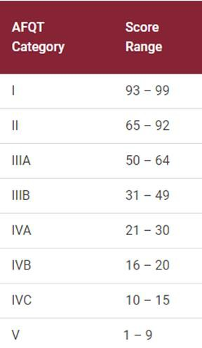*Sleeve tattoos for the Army, Marine Corps, and Air Force may not pass the wrist bone

### ASVAB

The Armed Services Vocational Aptitude Battery (ASVAB) is a test used by the United States to determine enlistment eligibility, assign military jobs, and help students explore careers. The test measures in four areas: Verbal, Math, Science and Technical, and Spatial. Students will receive a score on the Armed Forces Qualification Test (AFQT). These scores are percentiles between 1-

99. Percentile scores indicate how each examinee performed compared with the base youth population. If a student scored a 75, they scored higher than 75% of those who took the test. The minimum AFQT score varies according to a branch of service.

The ASVAB requirements for the military branches are listed below. These may be subject to change, so please check with your recruiter. Study guides for the ASVAB can be found [here](https://uniontestprep.com/asvab), and the CCC website will also have additional resources.

|  |  |  |  |  |  |
| --- | --- | --- | --- | --- | --- |
|  | **Navy** | **Army** | **Marine Corps** | **Air Force** | **Coast Guard** |
| **Score** | 31 | 31 | 31 | 50 | 40 |

### Military Recruiter Contact Information*

|  |  |
| --- | --- |
| **Air Force Marcus Miller**  US Air Force National Guard [Marcus.miller.10@us.af.mil](mailto:Marcus.miller.10@us.af.mil) 478.538.2467 | **Marine Corps Jeremy Newsome**  US Marine Corps [jeremy.newsome@marines.usmc.mil](mailto:jeremy.newsome@marines.usmc.mil) 904.402.2857 |

|  |  |
| --- | --- |
| **Army Jeffrey Sharp**  US Army [Jeffrey.L.Sharp8.mil@army.mil](mailto:Jeffrey.L.Sharp8.mil@army.mil) 678.923.8868  **Michael Coss**  US Army [michael.j.coss.mil@mail.mil](mailto:michael.j.coss.mil@mail.mil) 470.829.8815  **Rukiya Parsons**  US Army Georgia Army National Guard [Rukiya.k.parsons.mil@army.mil](mailto:Rukiya.k.parsons.mil@army.mil) 470.618.4084 | **Navy Alan Espino**  US Navy [alan.a.espino.mil@us.navy.mil](mailto:alan.a.espino.mil@us.navy.mil) 470.366.1997  **Lawrence Blackmon**  US Navy [lawrence.blackmon@navy.mil](mailto:lawrence.blackmon@navy.mil) 678.305.9134 ext. 2003 |
| **Coast Guard Atlanta Office**  1100 Hammond Drive NE Suite 460B  Atlanta, GA 30328  Phone: (206) 815-6150  Email: [ROAtlanta@uscg.mil](mailto:ROAtlanta@uscg.mil) | |

*Recruiters information above is from recent years – this will be updated upon verification of new personnel*

### Military Commissioned Officer Route

* Commissioned officers generally enter the Military with a four-year college degree or higher. In certain cases, enlisted service members can advance and transition to officers during the course of their military career as well. Officers are employed in management roles or highly specialized fields that require professional degrees (e.g., doctors, lawyers and chaplains). Their duty is to lead. An officer’s education often determines which career they will have in the Military. Candidates will meet with a military advisor or career counselor during college to select a potential job specialty.

##### Methods of Becoming an Officer

* Attend a senior military college or service academy
  + These highly competitive schools are virtually free of charge for those accepted. The government pays for each student’s tuition, room and board, uniform and books. Students are sometimes given a living stipend as well to help cover fees, a personal computer and other class supplies. In return, the student commits to serving as an officer for a set period after graduation, usually five years.
* Enroll at a college with a Reserve Officers' Training Corps (ROTC) program
  + ROTC programs provide officer training for students during college in exchange for scholarship money. In return, the students commit to serving for a set period of time after graduation.
* Attend Officer Candidate School (OCS) after graduating from college
* Receive a direct commission after earning a professional degree
* Advance through the enlisted ranks and then complete officer training

##### College ROTC Programs

Georgia Colleges with Army ROTC

* Agnes Scott College
* Augusta State University
* Clark Atlanta University
* Clayton State University
* Columbus State
* East Georgia State
* Emory University
* Fort Valley State
* Georgia Military College
* Georgia Southern
* Georgia State
* Georgia Tech
* Kennesaw State University
  + Mercer University
  + Morehouse College
  + Savannah State
  + Spelman College
  + University of Georgia
  + University of North Georgia

Georgia Colleges with Navy/Marine Corps ROTC

* + - Georgia Tech
    - Georgia State University
    - Savannah State University
    - Kennesaw State University

Georgia Colleges with Air Force ROTC

* + - * Agnes Scott College
      * Clark Atlanta University
      * Clayton State University
      * Emory University
      * Georgia Military College
      * Georgia State University
      * Georgia Tech
      * Kennesaw State University
      * Morehouse College
      * Oglethorpe University
      * Spelman College
      * University of Georgia
      * University of West Georgia
      * Valdosta State University

## Workforce

Some of our students are interested in going straight into the workforce or doing an apprenticeship (generally a multi-year program that pays for an employee’s on-the-job training such as the [Independent Electrical Contractors’ program](https://iecatlantaga.org/apprenticeship/program/)). The advisers can help them prepare for these roles!

[List of contacts from employers in the trades and apprenticeship programs](https://docs.google.com/spreadsheets/d/1EFqqOjf-3HbSEvdSx2xSaamiAXszpeINj45YO2D4xl8/edit?usp=sharing)

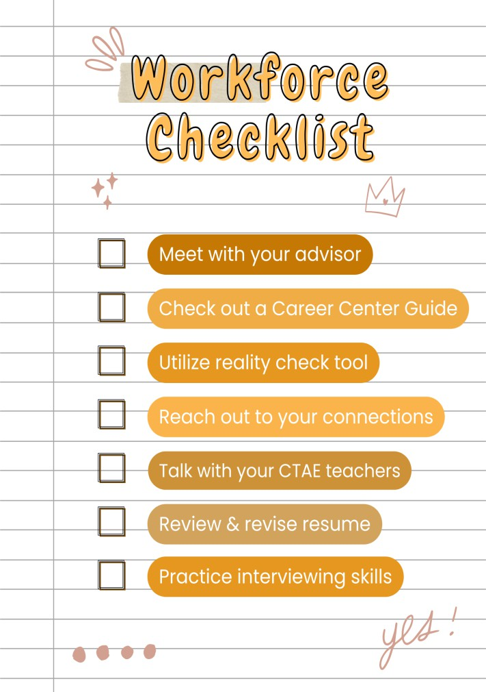

## Gap Year/Other Opportunities

Other students may feel undecided about what they’d like to do after they graduate, need a break from school before going to college, or are looking for a unique opportunity to explore career options. They can consult [this list of gap year opportunities.](https://docs.google.com/document/d/1bKO10T_A_C8NwY5yRwKAUYqOycl5duJhX8aJ9YDq0gw/edit?usp=sharing)

The two main ways that students take a gap year, or years is by either delaying their application submission, or deferring their acceptance.

Options also exist for students to apply to a postsecondary program, get accepted, and defer their acceptance. If students have received a financial aid package and decide to take a gap year it is important to know that they are not guaranteed the same package when they decide to enroll.

Additionally, it is important to consider that if a student works during their gap year their income will need to be reported on the FAFSA and may affect their award amount.